**REPORT**

|  |
| --- |
| **Experiment 1:** **RC circuit with unit feedback** |

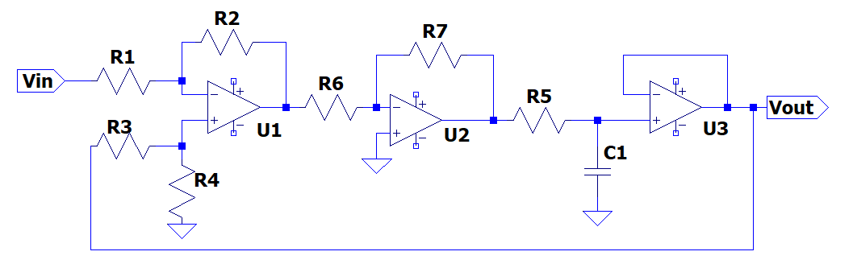

5V

5V

-5V

-5V

5V

-5V

|  |  |  |  |
| --- | --- | --- | --- |
|  | **rise time** (s) | **delay time** (s) | **steady-state error (V)** |
| **Theoretical Result** |  |  | **0.5** |
| **Experiment Result** | **0.285** | **0.080** | **0.530** |
| **Simulation Result** | **0.2197** | **0.0737** | **0.5000** |

注意事項:請參考投影片第5頁的定義

1. Calculate the **closed loop transfer function**.
$$V_{out}=-1×\left(V_{out}-V_{in}\right)×\frac{1}{0.2s+1}$$

$$⟹\left(0.2s+1\right)V_{out}=-V_{out}+V_{in}$$

$$⟹\left(0.2s+2\right)V_{out}=V_{in}$$

$$⟹{\underline{\frac{V_{out}}{V_{in}}=\frac{1}{0.2s+2}}}_{\#}$$

2. Vout and Vin waveform (1 pic):

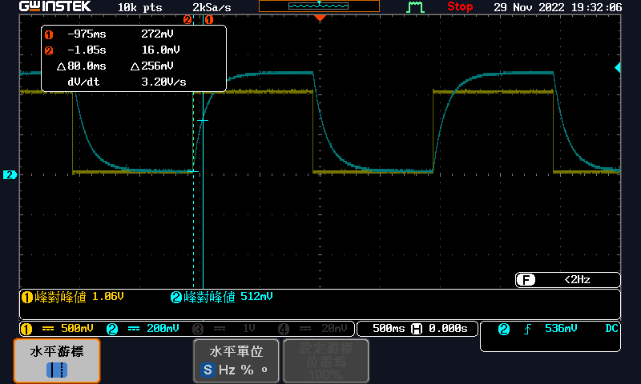

1. Simulation

Closed loop transfer function from command window:

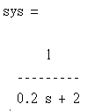

The unit step response(1 pic):

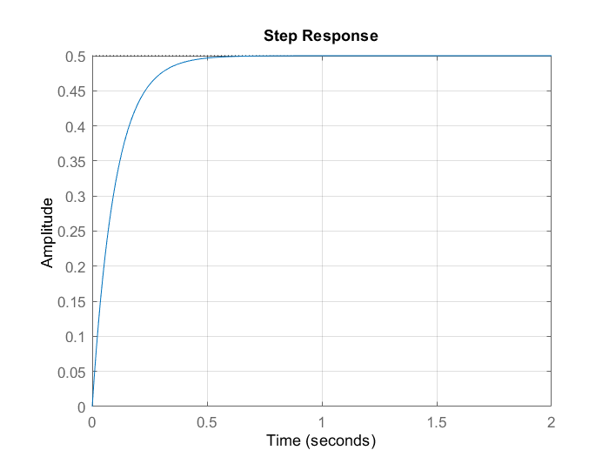

ans =

struct with fields:

RiseTime: 0.2197

SettlingTime: 0.3912

SettlingMin: 0.4523

SettlingMax: 0.5000

Overshoot: 0

Undershoot: 0

Peak: 0.5000

PeakTime: 1.0546

delayTime =

0.0737

sserror =

0.5000

|  |
| --- |
| **Experiment 2: RC circuit with P-controller and unit feedback** |



5V

5V

-5V

-5V

5V

-5V

|  |  |  |  |
| --- | --- | --- | --- |
|  | **rise time** (s) | **delay time** (s) | **steady-state error (V)** |
| **Theoretical Result** |  |  | **0.0909** |
| **Experiment Result** | **0.050** | **0.014** | **0.1** |
| **Simulation Result** | **0.0399** | **0.0134** | **0.0909** |

注意事項:請參考投影片第5頁的定義

1. Calculate $K_{P}$ and the **closed loop transfer function**.

Assume $V_{2}$ is the output of U1. The relation of input and output of difference amplifier:

$$V_{2}=V_{out}-V_{in}$$

Assume $V_{3}$ is the output of U2. The relation of input and output of inverting amplifier:

$$\frac{0-V_{2}}{R_{6}}+\frac{0-V_{3}}{R_{7}}=0$$

$$⟹V_{3}=-\frac{R_{7}}{R_{6}}V_{2}$$

Substitute $V_{2}=V_{out}-V_{in}$:

$$=\frac{100}{10}\left(V_{in}-V_{out}\right)$$

$$=10\left(V_{in}-V_{out}\right)$$

The relation of input and output of plant:

$$10V_{in}-10V_{out}=\left(sR_{5}C_{1}+1\right)V_{out}$$

$$⟹V_{out}=\frac{10V_{in}}{sR_{5}C_{1}+11}$$

$$⟹{\underline{K_{p}=10}}_{\#}$$

$$⟹{\underline{V_{out}=\frac{10}{0.2s+11}V_{in}}}_{\#}$$

1. Vout and Vin waveform (1 pic):

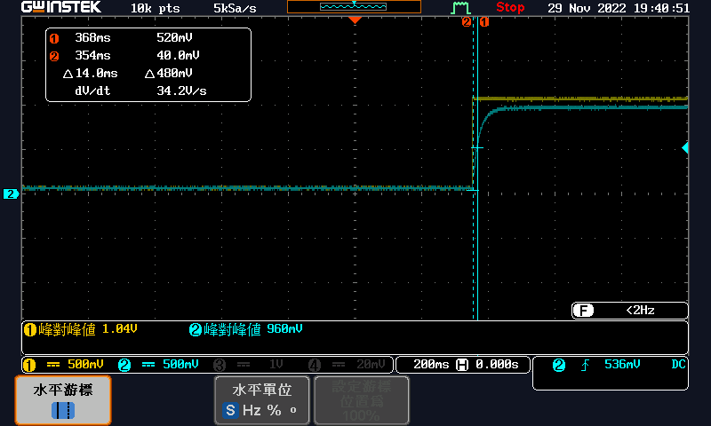

1. Simulation

Closed loop transfer function from command window:

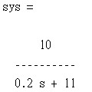

The unit step response(1 pic):

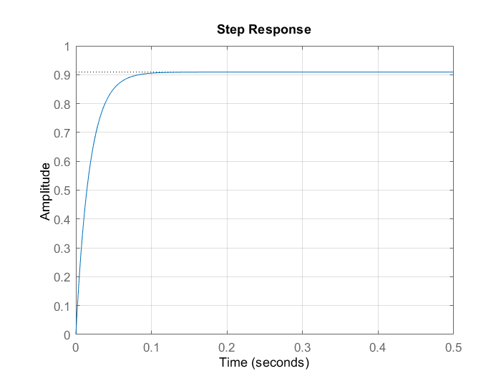

ans =

struct with fields:

RiseTime: 0.0399

SettlingTime: 0.0711

SettlingMin: 0.8223

SettlingMax: 0.9091

Overshoot: 0

Undershoot: 0

Peak: 0.9091

PeakTime: 0.1917

delayTime =

0.0134

sserror =

0.0909

**Discuss:**  
Try to explain the effect of the gain $K_{P}$ on the overall system.

Make the response faster and improve the steady state error.

|  |
| --- |
| **Experiment 3: RC circuit with I-controller and unit feedback** |

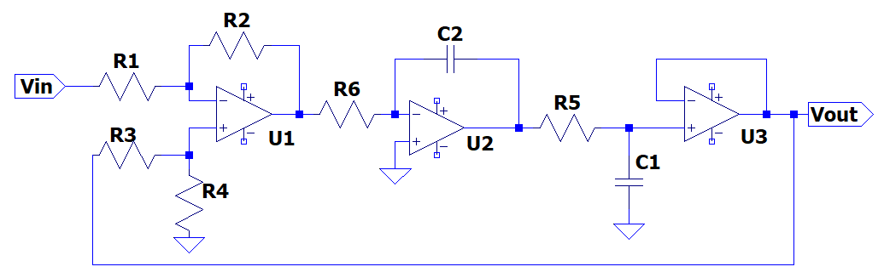

5V

5V

-5V

-5V

5V

-5V

|  |  |  |  |  |  |  |
| --- | --- | --- | --- | --- | --- | --- |
|  | **Maximum overshoot (%)** | **peak time (s)** | **rise time (s)** | **delay time (s)** | **settling time for 5% (s)** | **steady-state error (V)** |
| **Theoretical Result** |  |  |  |  |  | **0** |
| **Experiment Result** | **52.83** | **0.150** | **0.092** | **0.055** | **1.31** | **0.010** |
| **Simulation Result** | **70.2118** | **0.1405** | **0.0509** | **0.2817** | **1.5630** | **0.0064** |

注意事項:請參考投影片第7頁的定義

1. Calculate $K_{I}$ and the **closed loop transfer function**.

The output of U1 $V_{1}$ is equal to

$$V_{1}=V_{out}-V_{in}$$

The relationship between $V_{1}$ and $V_{2}$ around U2 is

$$\frac{0-V_{1}}{R_{6}}+\frac{0-V_{2}}{\frac{1}{sC_{2}}}=0$$

Substitute $V_{1}=V_{out}-V_{in}$:

$$⟹V_{2}=\frac{1}{sC_{2}R_{6}}\left(V_{in}-V_{out}\right)$$

$$=\frac{1}{0.01s}\left(V_{in}-V_{out}\right)$$

$$⟹{\underline{K_{I}=100}}_{\#}$$

The relationship between $V_{2}$ and $V_{out}$:

$$\frac{V_{out}-V_{2}}{R_{5}}+\frac{V_{out}}{\frac{1}{sC_{1}}}=0$$

$$⟹V_{out}-V_{2}=-sC_{1}R_{5}V_{out}$$

Substitute $V_{2}$:

$$⟹\left(sC_{1}R_{5}+1\right)V_{out}=V_{2}=\frac{1}{0.01s}\left(V_{in}-V_{out}\right)$$

$$⇒\left(0.2s+1\right)\left(0.01s\right)V_{out}+V_{out}=V_{in}$$

$$⟹\left(\frac{1}{500}s^{2}+\frac{1}{100}s+1\right)V_{out}=V_{in}$$

$$⟹{\underline{V_{out}=\frac{1}{0.002s^{2}+0.01s+1}V_{in}}}_{\#}$$

1. Vout and Vin waveform (1 pic):

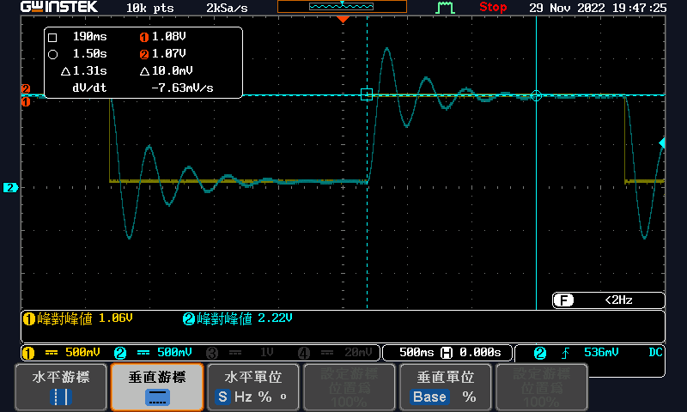

1. Simulation

Closed loop transfer function from command window:

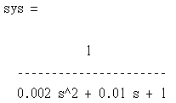

The unit step response(1 pic):

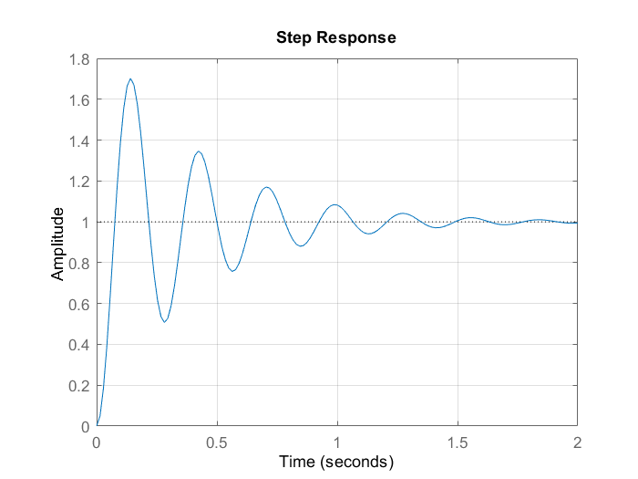

ans =

struct with fields:

RiseTime: 0.0509

SettlingTime: 1.5630

SettlingMin: 0.5072

SettlingMax: 1.7021

Overshoot: 70.2118

Undershoot: 0

Peak: 1.7021

PeakTime: 0.1405

delayTime =

0.2817

sserror =

0.0064

**Discuss:**

Try to explain why the steady-state error is close to zero and the effect of the gain $K_{I}$ on the overall system.

When the output reach steady state, capacitor C2 will be open circuit because the current through it $\frac{V_{out}-V_{in}-0}{R_{6}}$ is approximately 0. Therefore, the steady state error is close to zero.

The effect of the gain $K_{I}$ is to eliminate the steady state error.

|  |
| --- |
| **Experiment 4: RC circuit with PI-controller and unit feedback** |

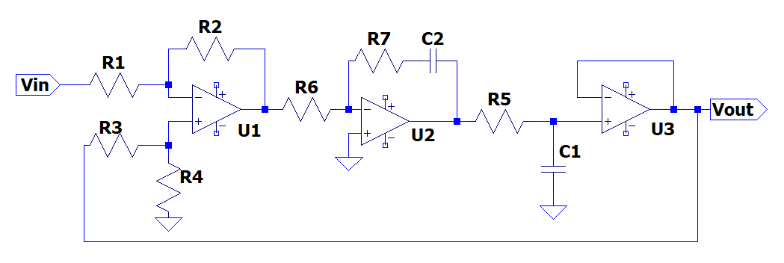

5V

5V

-5V

-5V

5V

-5V

|  |  |  |  |  |  |  |
| --- | --- | --- | --- | --- | --- | --- |
|  | **Maximum overshoot (%)** | **peak time (s)** | **rise time (s)** | **delay time (s)** | **settling time for 5% (s)** | **steady-state error (V)** |
| **Theoretical Result** |  |  |  |  |  | **0** |
| **Experiment Result** | **3.774** | **0.085** | **0.070** | **0.019** | **0.198** | **0.004** |
| **Simulation Result** | **4.8838** | **0.0974** | **0.0358** | **0.0127** | **0.2007** | **0.00064794** |

注意事項:請參考投影片第7頁的定義

1. Calculate $K_{P}$, $K_{I}$ and the **closed loop transfer function**.

The difference amplifier:

$$V_{1}=V_{out}-V_{in}$$

The PI controller:

$$\frac{0-V_{1}}{R_{6}}+\frac{0-V_{2}}{R_{7}+\frac{1}{sC_{2}}}=0$$

$$⟹\frac{V_{2}}{\frac{sC_{2}R_{7}+1}{sC_{2}}}=-\frac{V_{1}}{R_{6}}$$

$$⟹V_{2}=-\frac{1}{R_{6}}×\frac{sC_{2}R_{7}+1}{sC_{2}}V_{1}$$

$$=-\frac{C_{2}R_{7}s+1}{sC_{2}R_{6}}V_{1}$$

$$=\frac{\frac{s}{10}+1}{\frac{s}{100}}\left(V_{in}-V_{out}\right)$$

$$=\frac{10s+100}{s}\left(V_{in}-V_{out}\right)$$

$$⟹{\underline{K_{p}=10,K_{I}=100}}_{\#}$$

The plant:

$$\frac{V_{out}}{\frac{1}{sC_{1}}}+\frac{V_{out}-V_{2}}{R_{5}}=0$$

$$⟹\left(sC_{1}R_{5}+1\right)V_{out}=V_{2}$$

$$⟹V_{out}=\frac{1}{sC_{1}R_{5}+1}V_{2}$$

$$=\frac{1}{0.2s+1}\left(\frac{10s+100}{s}\right)\left(V_{in}-V_{out}\right)$$

$$=\frac{10s+100}{0.2s^{2}+s}\left(V_{in}-V_{out}\right)$$

$$⟹V_{out}=\frac{\frac{10s+100}{0.2s^{2}+s}}{1+\frac{10s+100}{0.2s^{2}+s}}V_{in}$$

$$⟹{\underline{V_{out}=\frac{10s+100}{0.2s^{2}+11s+100}V_{in}}}_{\#}$$

1. Vout and Vin waveform (1 pic):

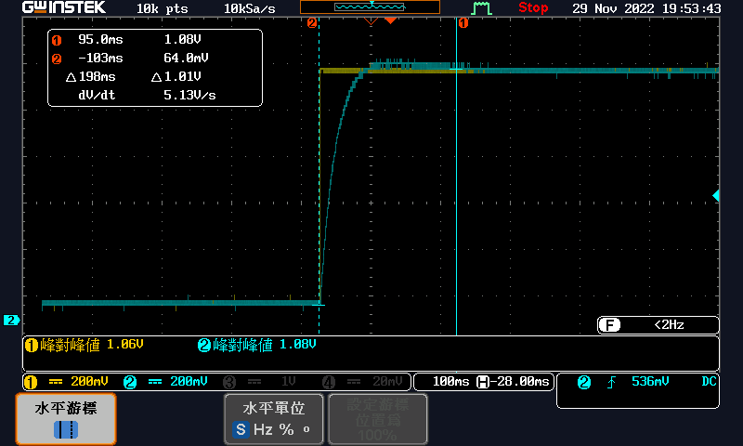

1. Simulation

Closed loop transfer function from command window:

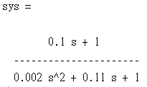

The unit step response(1 pic):

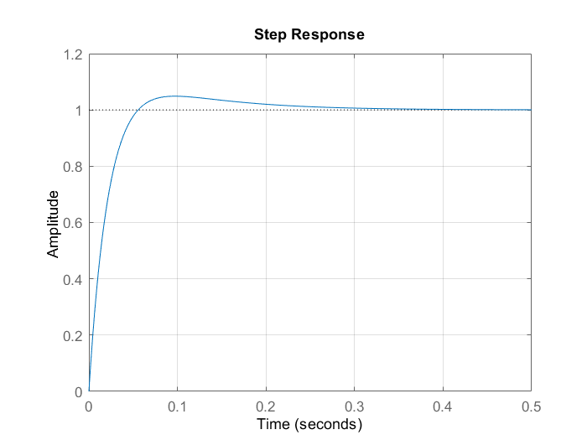

ans =

struct with fields:

RiseTime: 0.0358

SettlingTime: 0.2007

SettlingMin: 0.9017

SettlingMax: 1.0488

Overshoot: 4.8838

Undershoot: 0

Peak: 1.0488

PeakTime: 0.0974

delayTime =

0.0127

sserror =

6.4794e-04

**Discuss:**

Try to explain the effect of PI-controller on the overall system and how to design $K_{P}$ and $K_{I}$.

The PI-controller both the rise time and the steady state errors of the system.

Increasing $K_{p}$ results in a faster response of the control system. However, an increase in $K_{p}$ above a certain value can make the system unstable.

Increasing $K_{i}$ helps in eliminating steady-state error, but increases oscillations and overshoot.